## Merchant Name- Keen Decision Systems Implementation POC: Royce *(IM to fill)* CX POC: *[IMP to Add]*

### 

| Notes Sections   *(AE to fill if they have, Implementation to be completion DRI on handoff)* [Additional IM Prep Materials](https://docs.google.com/document/d/1DuRyqZnyPHDc9dOA9sVRzuDmn8_qassbSmCxflCwjFQ/edit?tab=t.0#heading=h.cey5dbnfz79y) *See This document for supplemental info*   * Info on how merchant bills   Keen’s billing is **non-standard** and **labor-intensive** under their current system (Maxio + QBO):   * **Manual Invoice Cadence Creation**: Every new contract requires manual setup of invoice schedules in Maxio. No automation, even for renewals. * **Edge Cases**: Occasionally use milestone-based or staged billing. These take 1+ hours per contract to set up correctly in Maxio. * **Custom Invoice Frequencies**: 6-installment plans, odd pricing, and staggered billing schedules are common and difficult to manage. * **Cash Application is Manual**: Mike manually logs into the bank daily to match payments and shut off collections cadences. * **Sales Tax Issues**: Maxio doesn’t integrate cleanly with Anrok, causing disputes with customers over missing or incorrect tax.   1) What is the merchant temperament? **👤 Mike Althoff (COO, Decision Maker)**  * Practical, sharp, and **cost-sensitive** * Wants to **minimize burden** on Keen and Expo (paid hourly) * Skeptical of shiny new tech — needs proof that Tabs reduces hours and won’t increase close time * He's done the heavy lifting to get Maxio working and is **reluctant to switch unless ROI is clear** * Final decision likely hinges on:    + Price vs. Maxio renewal ($32K Tabs vs. $40–44K Maxio)   + Time burden on Expo   + Jack’s confidence in reporting parity  **👤 Jack Siegel (CFO, Key User)**  * Detail-oriented, reporting-focused * Very responsive and solutions-oriented * His main concern is **ensuring close process speed doesn’t suffer** * Confident in Tabs if the **journal entries and rev rec reports** are sufficient * Would prefer a **dummy report** showing deferred/unbilled values to confirm confidence   3) What are the Tabs features that the key POC cares about? **💵 Billing Automation & Accuracy** **🔹 Critical**   * **Automated invoice schedule creation from contracts**  They struggle with manual cadence setup in Maxio, especially for custom/staged billing. * **Support for edge cases (e.g., milestone billing, staggered payments)**  Painful to configure manually in Maxio; even rare edge cases (every ~2 months) take over an hour. * **Support for multi-entity invoicing from a single contract**  (e.g., Revlon + Elizabeth Arden invoiced separately)  Tabs promised to handle this via dual customer records.   **🔹 Important**   * **Anrok integration for sales tax**  Incorrect or missing tax lines have caused customer disputes and non-payment.  **📥 Collections & Cash Application** **🔹 Critical**   * **Collections automation + cadence management**  Mike is manually turning off dunning campaigns based on bank activity. Wants this to be automatic. * **AI-powered cash application via Plaid**  He currently logs into the bank daily to reconcile; Tabs’ direct feed + match is a major selling point.   **🔹 Important**   * **Slack escalation and HubSpot visibility for overdue invoices**  He wants CSMs alerted without manual steps. Integration with shared Slack channels is appealing.  **📊 Reporting & Rev Rec** **🔹 Critical**   * **Rev rec journal entry export + QuickBooks compatibility**  Jack needs one-click journal entries that plug into QBO with correct debit/credit accounts. * **Deferred / unbilled revenue reporting**  Required for month-end and to maintain confidence with Expo and Mike. * **No increase in close timeline**  Reporting workflows must not add time to Expo Group’s monthly close. Core blocker if not addressed.   **🔹 Important**   * **Custom report support via backend (Omni)**  Tabs has committed to custom reports while native features are being built.   **🔹 Nice-to-have**   * **Auto-sync journal entries to QuickBooks (bypassing manual import)**  Considered useful, but optional depending on comfort.  **📈 ARR / CAR Waterfall Reporting** **🔹 Critical**   * **Committed ARR (CAR) waterfall tracking**  Must include:    + Contract signature date as commit date   + Renewal forecasting assuming auto-renew   + Churn detection via lost renewal deals in HubSpot * **Live dashboard visibility**  Mike wants to check ARR/CAR any time, even before Expo closes the month.   **🔹 Important**   * **Support for expansion, contraction, churn cohorts**  Useful for board reporting and later M&A diligence.  **🔄 System Integration & Syncing** **🔹 Critical**   * **Two-way sync with QuickBooks**  Maxio's limitations have led to issues updating billing contacts across systems. * **Phase 2: HubSpot integration for invoice status, renewals, and alerts**  Jack and Mike both expressed interest in syncing custom fields (e.g., 60-day notice periods).   **🔹 Nice-to-have**   * **Push renewal opps to HubSpot automatically**  Not required now, but Mike liked the direction. |
| --- |

### Billing model *(Entire Section: Implementation to fill section)*

* Are there unique things about the customer creation process for this merchant?
* Information on how merchant bills
* How contract is broken up
* One off things to know about the merchant

### Contract Processing Steps *(Entire Section: Implementation/Success to fill Post-Go Live)*

### **Customer Creation**

* + If it’s not a renewal, upsell or expansion and the customer doesn’t already exist, we should be creating the customer

### **General Guidance**

* + Most contracts are standard Keen Order Forms
    - Ignore any “Third Party Agreements”
    - Ignore POs unless it’s the first document we have for that customer
  + However, we also need to process Emails from HubSpot
    - Will look like the below ([Example](https://garage.tabsplatform.com/prod/contracts/b88c5005-4645-4258-90c7-41198771a038/terms/key))

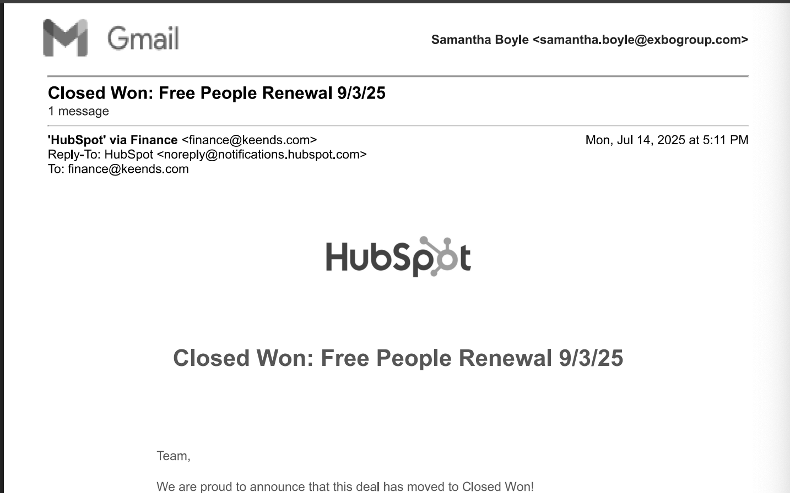

* + - * All of the instructions to process will be in the email
  + Process discounts IN-LINE. *Do Not create a separate BT*
* **Item Name:** Use the name of the product or service in the "Product" column
* **Item Description:**
  + Add if appropriate but do not include long descriptions - doesn’t need to be longer than a sentence.
* **Quantity:** Use the "Quantity" column; default to 1 if not listed.
* **Total Price:** Use the full price listed for each service period
* **Service Start Date:** Use the "Service Period" start date for each individual line item.
* **Months of Service**
  + Use the number of months implied by service period (e.g., 12 months for full-year, 3 months for pilot).
  + Round based on whole months between start and end.
* **Billing Start Date**
  + Default to service start date unless a different invoicing date is explicitly listed
    - For example - under payment terms sometimes there is language
      * + “The total annual fees listed in the services section, above, will be invoiced to Client in 2 parts; year 1 on 03/01/2024 for 179k and year 2 on 3/01/2025 for $179k.”

Follow these dates in this case

* **Integration Item:** “Subscription Revenue” for all
* **Frequency:** stated in contract terms
* **Net Terms**: If not listed, default to 30.
* **IGNORE**
  + Ignore any BTs named “incremental __”
  + Ignore any BTs named “State/regional taxes”
    - DO NOT process any BTs for taxes

1. Anything to ignore in contracts?
2. Specifics processing things the merchant has requested that may differ by contract (e.g. always back-date invoice date to final day of the month)
3. Default Service Term
   1. If None Listed, Ops Default is 1 Year
4. Default Net Payment Terms
   1. If None, Ops Default is 0
5. Default Billing Frequency
   1. If None Listed, Ops Default is Monthly
6. How do we handle taxes as a line item?
   1. If None Listed, Ops Default is every tax line item becomes a BT

### Events Processing (if necessary) *(Entire Section: Implementation/Success to fill Post-Go Live)*

* Any important information on events billing

Integration Items Processing (if necessary)  
*(Entire Section: Implementation/Success to fill Post-Go Live)*

* What are the instructions for assigning integration items?
* Example: All Statsig integrations items should be labeled as “Sales”
* Example: All “Pinata” integration items should be labeled as “Software Subscription Bundle” unless otherwise noted by Merchant

Post Processing Communications (if necessary)  
*(Entire Section: Implementation/Success to fill Post-Go Live)*

* Does the Ops Team need to notify anyone on the team re: completion of processing batches in Implementation or Active phase?
* Who needs to be notified and when?
  + Example:
    - Who: Customer Success [Azmat Aziz] needs to be notified
    - Where: Messari internal merchant channel
    - When: contracts are processed [Merchant Phase: Active]

### Customer Information *(Entire Section: Implementation/Success to fill Post-Go Live)*

* Any important information on specifics customers of this merchant
  + Special memo’s certain invoices require
  + Invoice changes due to merchant/customer relationship

### Feature Requests *(AE to fill for all requests prior to Imp handoff, Imp to fill prior to go-live/Success to fill to fill Post-Go Live)*

* FR 1
  + What is it
  + Why it's important
  + Urgency

### Merchant Calls *(AE to fill for all videos prior to Imp involvement, Imp to fill prior to go-live/Success to fill to fill Post-Go Live)*

* March 31 intro call - <https://us-56595.app.gong.io/call?id=4681154410999237495>
* April 2 custom demo - <https://us-56595.app.gong.io/call?id=378492330074115210>
* April 3 scoping call - <https://us-56595.app.gong.io/call?id=5110652899652730931>
* April 15 reporting discussion with Jack - <https://us-56595.app.gong.io/call?id=2624889405392607887>